**REDANT INTERN TASK**

BY : Kowreesh G(1831030)

**Languages and tools used**: HTML, CSS, BOOTSTRAP, PHP, MYSQL

Outputs:

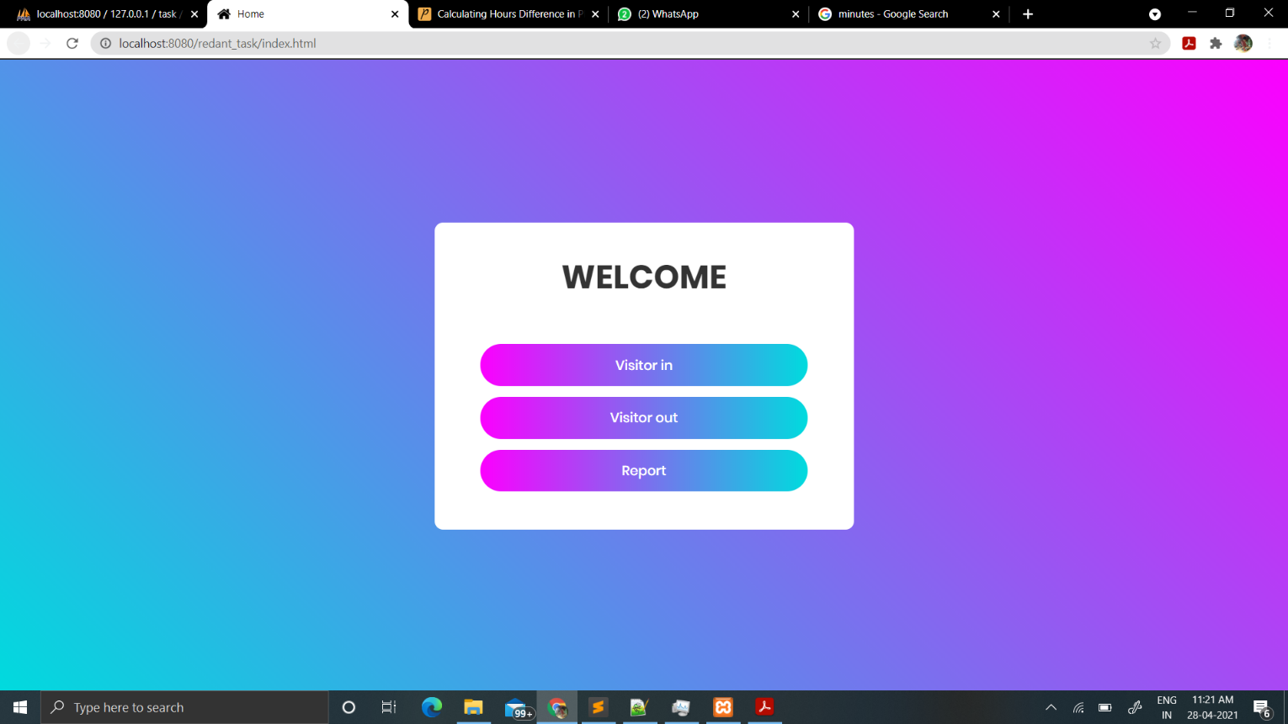

Visitors check in:

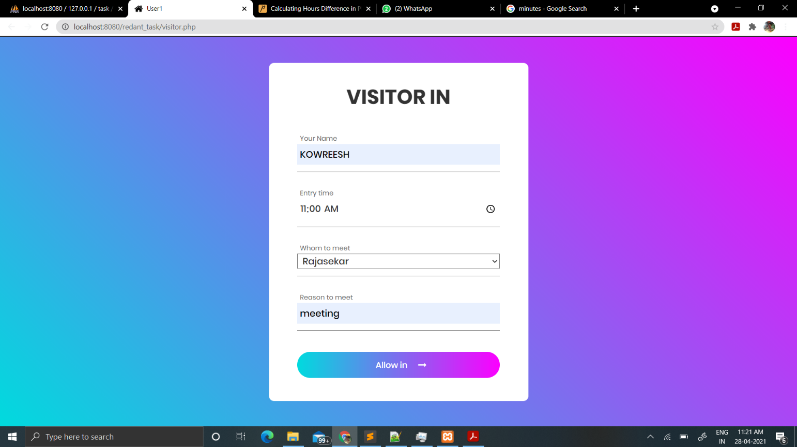

Visitors check out:

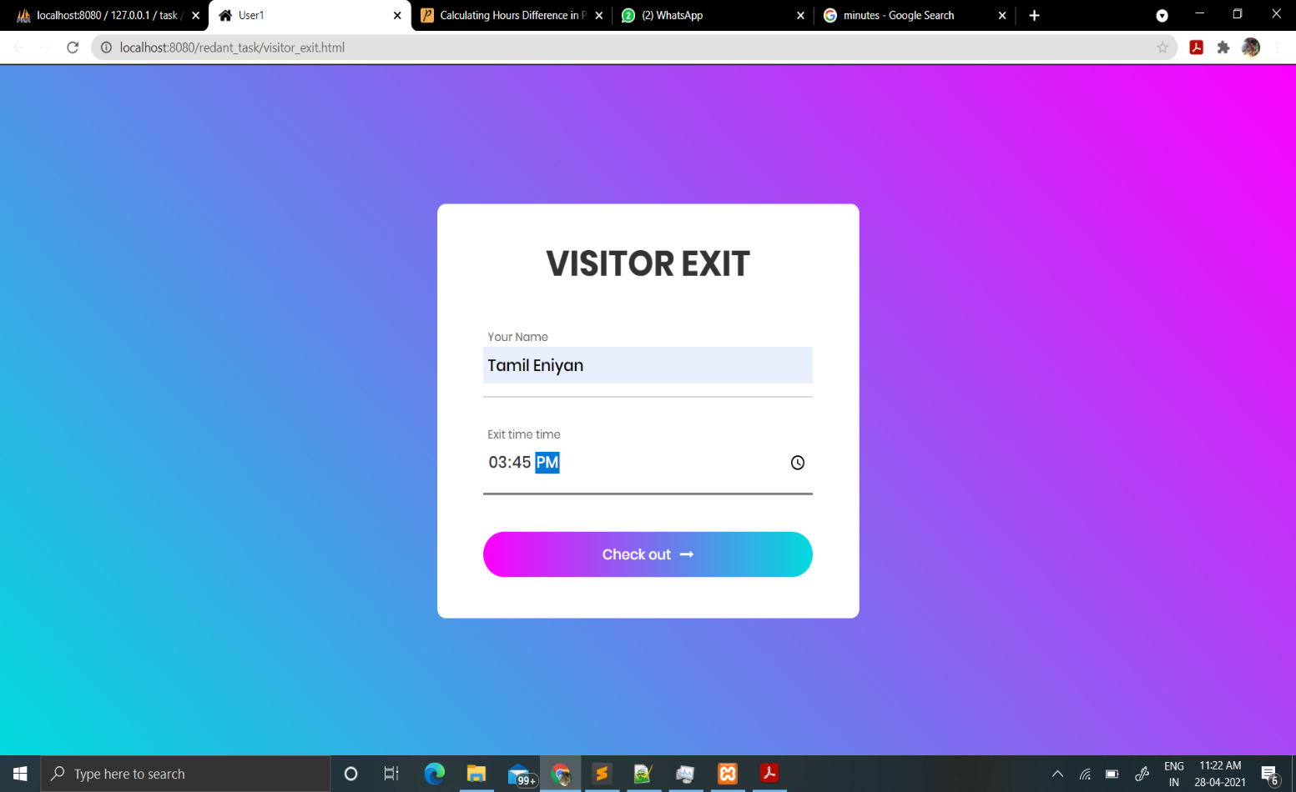

Report:

